**Slyggdrasil – Game Design Document**

**Content**

* **Overview**
* **Game mechanics**
* **Game content**
* **Environment Layout**
* **Media asset lists**

**Overview**

**General overview**

Slyggrasil – in short – is a tower climb style arcade game inspired and construed from a specific concept in Norse Mythology; The World Tree, also known as Yggdrasil. Yggdrasil’s main concept is that it is a tree in the center of the nine Norse realms; Midgard (Human realm), Muspelheim (Fire realm), Hel (Realm of the dead), Niflheim (Realm of ice and mist), Jotunheim (Realm of the giants), Alfheim (Elf realm), Svartalfheim (Dwarf realm), Vanaheim (Realm of the Vanir gods) and Asgard (Realm of the Æsir gods). It branches off into these realms and connects them all together. I used a similar concept to this, making my version of the world tree act as a tower that connects all the stacked layers of the game setting’s world into one. The players will climb the Slyggdrasil tree, passing the 9 layers of the world and seeing all the unique species that own the layers as this will be the main sense of progression that the game gives off.

The main thing the player will be doing is making constant jumps and bounces on platforms that become more difficult to reach as they go further up, to keep the players’ minds busy while climbing this seemingly dull and repetitive level structure, each level reached will grant a modification that the player themselves select. Not only will this make it easier to progress, it will also give them a downgrade that makes other aspects harder. On top of that, the game will involve two players with their own mass and strength, meaning that bumping into one another causes them to bounce and jump off of each other. The last thing to mention is that the backgrounds will be interactive with the levels, some backgrounds may cause platforms to freeze over and give them ice physics, while others may make the players swap textures for a set amount of time and make it more difficult to find which one they are controlling.

In my project proposal, I had started developing the story portion at the very start, meaning I had created a 5-paragraph page of narrative that I couldn’t use at that point. I’m glad that I can now share that part, below is the narrative that I plan to follow throughout the game’s development.

**Narrative**

In a world of insane variation – from vibrant fields of gasping flowers to eccentric belts of hazardous meteoric rock – you and your sibling belong to an adventure to rule an empire. The hyper, lively land of monsters’ spring with slimes in all flavors, spirits of steaming ascent, demons that know the truth of dance and flow, festive little skeletons, orcs who are truly at peace, elven constructors of mind-boggling homes, goofy and greedy goblins, holy and ethereal angels and finally aliens that know exactly how-to party. As you can already tell, the absolutely packed world inherits from the best kind of chaos – and just as human creatures do – there was once a humanoid person of flesh that planned to destroy our residents’ peaceful activities.

The human first appeared in the plains of the slimes. They perceived themselves as strong, valiant and the only one that can clear this land; unfortunately for them, they made the classic blunder of tripping on a rock and ending their journey right there and then. It was quite anticlimactic but this first blunder allowed a gigantic tree to grow and stretch past even the heavens, its branches growing into the homes of all the resident monsters and linked them together… without a ruler to quell the madness. This is exactly where you and your sibling’s journey begin.

Let’s introduce you. Thunar the brave; an honorable and lightly competitive sportsman of a slime have always embraced and encouraged your sibling, pushing them to improve through your seemingly friendly rivalry. Joined by Luku the envious; an objectively annoying and jealous slime that wished only to beat Thunar in their competitions, all of their efforts going towards “Showing Thunar who **really** deserves father Wutan’s respect.”. Despite their differences, they were both told by their beloved father Wutan that the massive tree – named the “Slyggdrasil Tree” – they grew up playing on actually leads to a whole new land, one that would allow them to become the ruler of their beloved stacks of homes. After being told the “prophecy” of sorts, both slimes rushed toward the massive goal to prove themselves to their own perceived glory. Before beginning their journey, it becomes obvious that Thunar is doing this to bring peace among the many levels of this world, while Luku is only here to prove a point that they are the one deserving of all Wutan’s love and compassion.

Throughout the journey, the siblings find that it is a **long** way down and best not to fall when climbing. They also discover new things with each milestone of the mission brings them a strange feeling, one that manipulates the space around them and changes the way the tree and its surrounding react when colliding with them. They see magnificent things, too, things like bursting active volcanoes, a huge ice-skating ring that blares disco music, a Christmassy town that rains presents, a forest of flaming coloured leaves, a city of impossible structures, a plain of rivers and lakes glittering with gleaming crystals, a sky of floating terrain and even a void that blinds them with the spiritual life of the party.

At the end of their long, unbelievable trek, they discover what they were told was their goal but realize one key piece of missing information: Only one entity can rule the lands and therefore they must truly compete for the final prize of royalty. One slime finally wins the lifelong race and the other takes the bounce of shame back down, closing off their tale with little closure other than one of them is superior in the most royal way possible: through competitive selection and elimination.

I also completed some work in character creation and design in reference to the main characters.

**Characters**

Below shows the first draft of the green, translucent slime that wears a crimson cape that flows when they jump and move around, by the name Thunar. Inspiration for the name – as is probably evident by the theme of the game’s narrative that was an adapted story from the world tree “Yggdrasil” – is the god of thunder “Thor”.

Thunar’s character was gone over in the narrative section but in summary, they are a brave slime of little competition, making their main goal in life a quest to help raise their sibling to be as well developed as them.

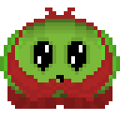

On the other hand, this is Luku, or the name it was inspired from “Loki”. The draft shows that they are a blue, translucent slime that wears a green, patterned piece of chest armour.

Just like Thunar, Luku was covered in the narrative section but as a refresher, Luku is a generally toxic family member, choosing competition and chaos over love or care for Thunar. They wish only to win and subdue, a real flip of the coin from Thunar’s character. 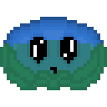

**Unique selling points**

Finally, after all this work being put into just the idea, what will make this worth it and why should players play my game rather than just going to the other machines to play some other game? I have 3 unique selling points to my game; In-depth story exploration, subversion of story tropes and low pay to play. As already explained above, the story for this idea is long and explored from corner to corner. Unlike most arcade games that have shallow story and only mechanical interaction, Slyggdrasil will explore both the mechanical enjoyment of its genre as well as the imaginative narrative enjoyment. As an extension of that, the tropes I have avoided and contrasted makes the game unique. For example: the game starts off by introducing this magical hero but uses the fact that heroes in games often have to respawn before reaching their goal to push the hero into the shadows and explore this world that the hero had planned to destroy instead. Lastly, the game’s arcade cabinet will use the game’s almost endless replay ability to justify the low charge price of around 10 pence; this will draw players to want to try out the game for almost no cost and then replay it again and again to try and reach the top or try out other playstyles.

**Game mechanics**

The main mechanics of the game come in a set of 4; Base gameplay, player modification, player interaction and background interactivity while the lesser mechanics will be discussed afterward.

**Base gameplay**

The base gameplay comes in the form of movement. Players will move across a multitude of platforms that have different effects, while not having to worry about jumping as they will have an auto jump that triggers when they collide with the top of the other player’s head and platforms with specific exceptions.

**Modifications**

The second of the main mechanics is the player modification. In brief, player mods will come as a set mod for each level. A modification is a package of an upgrade and a downgrade, for example;

|  |  |
| --- | --- |
| Modification information | Modification description |
| Modification level allocaction | Level 2: Ghopelheim |
| Modification name | Revival Curse |
| Modification upgrade | Upon dying, the player is revived and given another chance |
| Modification Downgrade | Player knockback is increased and can be bounced further by the other player |

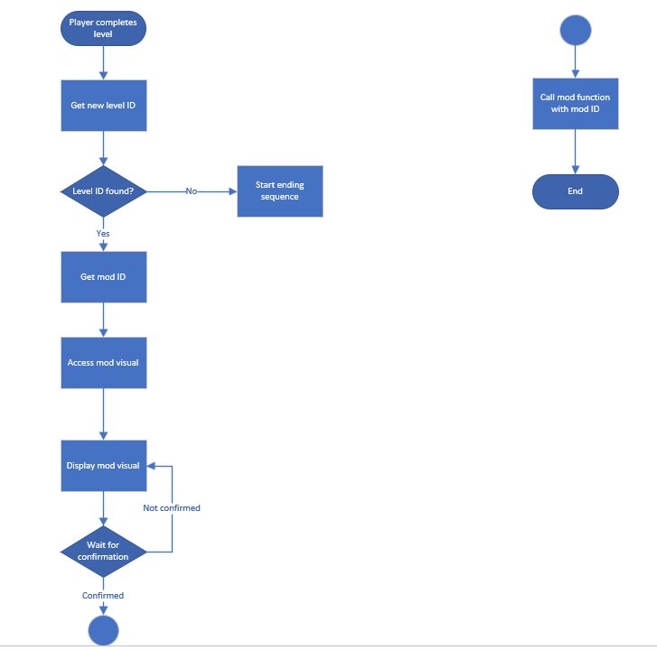

**Player interaction**

The third mechanic of the main three is player interaction. This was originally just a technicality I realized might be a bug or a problem in the game but after putting some thought in, I thought it may end up working as a core mechanic. Throughout the game, the players will be able to move into each other and cause knockback to push each other around. This can be done by using Unity’s weight values for the objects and can easily be altered as a public variable when mods are being applied.

**Background interactivity**

The final main mechanic I want to go over is the background interactivity. Since I plan to have the backgrounds cheer the players on as they go further and further up, I came across the idea of having them actually interact with the player objects. To give an example, I plan to have one of the levels be the home of the amethyst goblins, a race of goblins obsessed with amethyst crystals. The interaction I would put in that level would be that amethyst crystal projectile objects would appear on the level screen as the goblins in the background screen throw them around. These objects, upon touching the player object would cause knockback to them. The way that these objects would spawn actually have nothing to do with the backgrounds, instead, they would spawn randomly at the top of the screen.

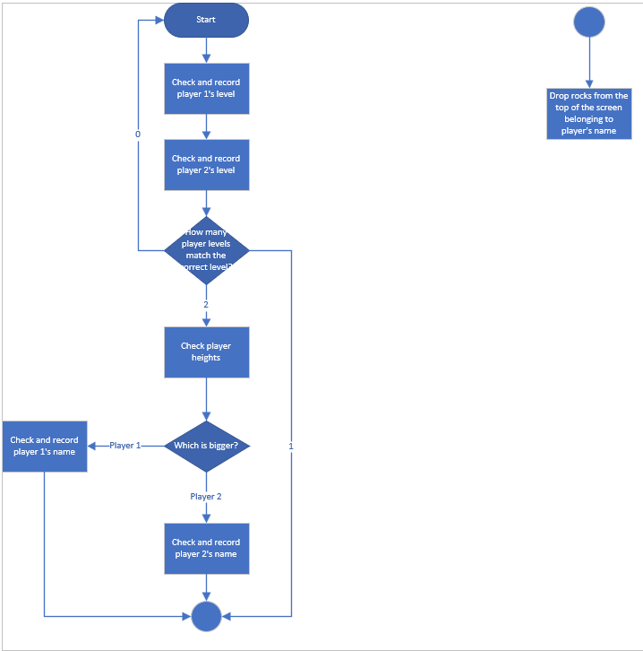

Now we’ve dealt with the main mechanics, the lesser mechanics must also be covered. This includes the controls, platforms, player death, player win, wall bounce, score counter, lives counter, player name display, upgrades display and the leaderboard.

**Controls**

The controls obey a tight control scheme that transfers arcade inputs to keyboard inputs as shown below:

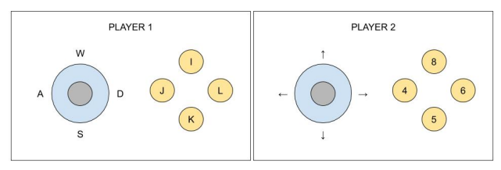 For the sake of simplicity and ease of referral when testing and implementing, the keyboard inputs will be put in the table below:

|  |  |  |
| --- | --- | --- |
| Player | Control function | Control key |
| 1 | Move left | A |
|  | Move right | D |
|  | Menu navigate up | W |
|  | Menu navigate left | A |
|  | Menu navigate right | D |
|  | Menu navigate down | S |
|  | Menu confirm | K |
| 2 | Move left | Left arrow |
|  | Move right | Right arrow |
|  | Menu navigate up | Up arrow |
|  | Menu navigate left | Left arrow |
|  | Menu navigate right | Right arrow |
|  | Menu navigate down | Down arrow |
|  | Menu confirm | Num pad 5 |

**Platforms**

The platforms are a level asset that work to stop the player’s gravity using Unity’s gravity system, they will simply stop the player from falling but may have altered mechanics based on the current level. Things like Hel’s ice rink theme may give the platforms ice physics that will keep the player’s momentum and allow them to slide along the platform.

**Player win, player death and wall bounce**

The player must have a way to win and this will be done at the final level in which reaching a trigger object like a door or opening in the roof would cause that specific player to have their own win screen. The player death and wall bounce are player actions that use the window’s border to trigger an action. If the player touches the bottom of the screen, they will have their lives decreased by one. If the player ever reaches 0 or less lives, their player object is destroyed. If both player objects are destroyed, a loss screen displays for a set time before the screen sets back to the main menu. Wall bounce uses the sides of the screen to inverse the player’s momentum, sending them the other direction to keep them on the screen.

**UI mechanics**

The score counter, lives counter, player name display and upgrades display are all user interface mechanics, below is a visual representation of the UI and how information will be fed back to the user;

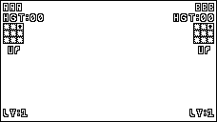

What this means:

Player 1 name: AAA

Player 2 name: BBB

Both players;

Current height: 00 meters

Lives count: 1

Upgrades: Empty Empty Revival Curse

Empty Empty Empty

Empty Empty Empty

The text aspects would be slightly transparent to allow the player space to see incoming objects

Tackling these mechanics, they will be stored as variables within the player object and will either be public or use a serialized field so they can be altered and displayed clearly. The one unique thing there is the name display. This will not change after it is set at the start of the game and will be recorded for the leaderboard system. Both players would enter their names at the beginning one after another, this is because the names need to be displayed on the UI throughout gameplay.

**Leaderboard**

Finally, tackling the leaderboard system; This is how data will persist throughout gameplay sessions using something like the playerprefs system in unity. The leaderboard will consist of 5 top players and will be displayed differently depending if the final score is a winner or not. It will be shown like this;

|  |  |  |
| --- | --- | --- |
|  | Player Name | Height |
| 👑 | JIM | 999 |
| 👑 | PAM | 999 |
|  | SAM | 555 |
|  | JOE | 222 |
|  | JEN | 001 |

The crowns next to the name displays they are a winner. If a player gets knocked off of the leaderboard, their data is erased.

**Game content**

**Objects contained**

**Player objects**

|  |  |  |
| --- | --- | --- |
| Object name | Level appearances | Brief description |
| Player-Thunar | All | The player object for player 1, used in all levels as it moves between them |
| Player Luku | All | The player object for player 2, used in all levels as it moves between them |

**Level geometry**

|  |  |  |
| --- | --- | --- |
| Object name | Level appearances | Brief description |
| Geo-BasePlatform | All | The basic platform that players jump on, used as a standard jumping platform. This will use a 3D asset |
| Geo-IcePlatform | 3 and 4 | The platforms that appear in level 3, they work with ice physics. This will use a 3D asset |
| Geo-FakePlatform | 5 | The platforms that appear in Level 5, they will not stop the player’s gravity and animate like falling leaves when stepped on. This will use a 3D asset |
| Geo-MovingPlatform | 8 | The platform introduced in Level 8, they will move on a set left to right path and work with collisions just as a base platform would. This will use a 3D asset |

**Obstacles**

|  |  |  |
| --- | --- | --- |
| Object name | Level appearances | Brief description |
| Obst-Fireball | 2 | The objects controlled by the background, knock the player around and be destroyed on collision |
| Obst-Present | 4 | The objects controlled by the background, they will speed up the player’s horizontal movement and spawn a new object on destruction |
| Obst-PresentContent | 4 | The object that the present object spawns on destruction, it turns base platforms into ice platforms |
| Obst-AmethystRock | 7 | The object controlled by the background, they will knock the player around, be destroyed on collision and spawn a group of other obstacles |
| Obst-AmethystPebble | 7 | The object spawned by the Amethyst rock object, they will push the player around and be destroyed on collision |
| Obst-Firework | 9 | The object controlled by the background, they will be destroyed on collision and increase player jump height |

**Backgrounds**

|  |  |  |
| --- | --- | --- |
| Object name | Level appearances | Brief description |
| Back-SlimeFields | 1 | The background object for Level 1: Slidgard |
| Back-FirePits | 2 | The background object for Level 2: Ghopelheim, this will affect the level geometry |
| Back-DiscoRink | 3 | The background for Level 3: Demol |
| Back-XmasTown | 4 | The background for Level 4: Skelheim, this will affect the level geometry |
| Back-AutumnForest | 5 | The background for Level 5: Orunheim, this won’t effect level geometry |
| Back-MagicTown | 6 | The background for Level 6: Elheim |
| Back-CrystalRiver | 7 | The background for Level 7: Gobelheim, this will affect the level geometry |
| Back-AngelIslands | 8 | The background for Level 8: Anaheim, this won’t affect level geometry |
| Back-MeteorBelt | 9 | The background for Level 9: Aligard, this will affect level geometry |

**User interface**

|  |  |  |
| --- | --- | --- |
| Object name | Level appearances | Brief description |
| UI-LevelCounter | All | The displayed counter that shows the player’s current level |
| UI-NameDisplay | All | The displayed tag that shows the player’s chosen name |
| UI-Height | All | The displayed counter that shows the player’s current height |
| UI-Mods | All | The graphic that displays the player’s equipped modification |
| UI-Mod1 | 2 | The modification visual showing the mod given at the start of level 2 on the mod menu |
| UI-Mod2 | 3 | The modification visual showing the mod given at the start of level 3 on the mod menu |
| UI-Mod3 | 4 | The modification visual showing the mod given at the start of level 4 on the mod menu |
| UI-Mod4 | 5 | The modification visual showing the mod given at the start of level 5 on the mod menu |
| UI-Mod5 | 6 | The modification visual showing the mod given at the start of level 6 on the mod menu |
| UI-Mod6 | 7 | The modification visual showing the mod given at the start of level 7 on the mod menu |
| UI-Mod7 | 8 | The modification visual showing the mod given at the start of level 8 on the mod menu |
| UI-Mod8 | 9 | The modification visual showing the mod given at the start of level 9 on the mod menu |

**Modifications**

Moving onto the modifications, each level apart from level 1 will have a modification, these mods and their properties are listed below;

|  |  |  |  |  |  |
| --- | --- | --- | --- | --- | --- |
| Level | Name | Upgrade desc | Downgrade desc | Upgrade stats | Downgrade stats |
| 2 | Revival curse | After death, the player gets another try at life | Player knockback is increased and can be bounced further by the other player | Lives+1 | Weight-10% of base weight |
| 3 | Icy adaptation | The player becomes adept to dealing with ice | The player becomes chilly and cold | Nullifies ice effects | Horizontal movement -5% of base horizontal movement |
| 4 | Christmas spirit | The player becomes jolly and happy, spreading their cheer everywhere | The player stuffs their face with food during their celebration | Player jump height -5% of base player jump height | Weight +15% of base weight |
| 5 | Fall’s greetings | The player jumps in a pile of leaves, making them happy | The player accidentally swallows a leaf | Player jump height +6% of base jump height | Weight +1% of base weight |
| 6 | Magical lift | The player gains a blessing from the elves, making them slightly float | The player becomes dizzy from the blessing | Gravity -1% of base gravity | Horizontal movement -1% of base horizontal movement |
| 7 | Goblin riches | The player becomes rich with crystals and jumps for joy | The player becomes heavier with their riches | Player jump height +2% of base jump height | Weight +1% of base weight |
| 8 | Revival curse | After death, the player gets another try at life | Player knockback is increased and can be bounced further by the other player | Lives+1 | Weight-10% of base weight |
| 9 | Alien technology | The player develops an alien mutation, making them lighter | The players are dazed by the change | Weight -2% of base weight | Player spites swap |

**Music content**

Other things to mention here are the different effects that the levels will have on the game. One of these effects is the music; The music will be a base track but each level will have its own version of this theme. The way I plan to do this is to have each track playing in sync but use an asset or audio manager to adjust the volume of the different tracks. Explaining this further, in level 1, there will be a country version playing at the max volume while the other 8 play silently. Then when the level changes to level 2, the country version will play silently and a new soul version will play at max volume instead. I have already planned the versions for each level;

|  |  |
| --- | --- |
| Level Number | Music theme |
| 1 | Country |
| 2 | Soul |
| 3 | Disco |
| 4 | Christmas/ Nightmare Before Christmas-esc |
| 5 | Instrumental |
| 6 | Light Fantasy |
| 7 | Dark Fantasy |
| 8 | Jazz |
| 9 | EDM |

**Environment layout**

**Level palettes**

Similarly, to the narrative and main characters, I have made pre-hashes of the different level colour palettes, below will show these palettes in respect to their level names;

|  |  |  |
| --- | --- | --- |
| Level number | Level name | Palette |
| 1 | Slidgard |  |
| 2 | Ghopellheim |  |
| 3 | Demol |  |
| 4 | Skelheim |  |
| 5 | Orunheim |  |
| 6 | Elheim |  |
| 7 | Gobelheim |  |
| 8 | Anaheim |  |
| 9 | Aligard |  |

**Level layout**

In the game, I have chosen to treat the levels as a transitional feed tape (Recording important variables between scenes) to make them flow like one continuous level; syncing the music to different themes. To display this in a more digestible fashion, I’ve created a level map to show the general flow of the game. Each coloured section shows the different level placement and the sprite in each section shows the different monster for that level.

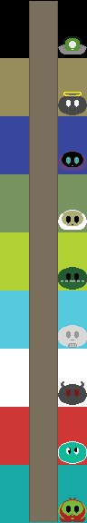

Each level contained in different scenes

Win state triggers here

To go a little deeper, here are drafts for a level layout of level 1, level 3, level 5 and level 8 as these are the levels in which level geometry types change. This is subject to change but gets the point across. The black bars show the base platform placement, the grey bars show the ice platform placement, the orange bars show the leaf platform placement, the gold bars show the moving starting platform placement while the purple bars show the destinations for the moving platforms which they will move continuously between using the white dotted line as a journey path. The green and blue blobs show the player characters.

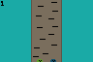

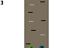

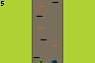

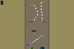

**Media asset lists**

|  |  |  |  |
| --- | --- | --- | --- |
| Animated sprites | | Made with Piskel | Total: 58 |
| **Name** | **Description** | | |
| Thunar jump | An animation showing player 1 jumping straight up in the air, the cape flapping below them is a key part of the animation. It would be used as the player’s y position is decreasing and they are not touching the ground. | | |
| Thunar fall | An animation showing player 1 falling straight down the air, the cape flapping above them is a key part of the animation. It would be used as the player’s y position is increasing and they are not touching the ground. | | |
| Thunar left jump | An animation showing player 1 jumping up and left in the air, the cape would lean to the right below them and would be used when the player’s y position is decreasing and when their x position is decreasing and they are not touching the ground. | | |
| Thunar right jump | An animation showing player 1 jumping up and left in the air, the cape would lean to the left below them and would be used when the player’s y position is decreasing and when their x position is increasing and they are not touching the ground. | | |
| Thunar bounce | When the players land on the ground, they will bounce and jump automatically, this animation will show a slight squish and make the cape fall below them before the jump animations are used again | | |
| Thunar left fall | An animation showing player 1 falling down left in the air, the cape leaning to the right above them. It would be used as the player’s y position is increasing and their x position is decreasing and they are not touching the ground. | | |
| Thunar right fall | An animation showing player 1 falling down right in the air, the cape leaning to the left above them. It would be used as the player’s y position is increasing and their x position is increasing and they are not touching the ground. | | |
| Luku jump | An animation showing player 2 jumping straight up in the air, the chest plate budged down on them is a key part of the animation. It would be used as the player’s y position is decreasing and they are not touching the ground. | | |
| Luku fall | An animation showing player 2 falling straight down the air, the chest plate budged up on them is a key part of the animation. It would be used as the player’s y position is increasing and they are not touching the ground. | | |
| Luku left jump | An animation showing player 2 jumping up and left in the air, the armor would budge to the right and down on them and would be used when the player’s y position is decreasing and when their x position is decreasing and they are not touching the ground. | | |
| Luku right jump | An animation showing player 2 jumping up and right in the air, the armor would budge to the left and down on them and would be used when the player’s y position is decreasing and when their x position is increasing and they are not touching the ground. | | |
| Luku bounce | When the players land on the ground, they will bounce and jump automatically, this animation will show a slight squish and make the armor settle in the middle of them before the jump animations are used again | | |
| Luku left fall | An animation showing player 2 falling down left in the air, the armor budging to the right and up on them. It would be used as the player’s y position is increasing and their x position is decreasing and they are not touching the ground. | | |
| Luku right fall | An animation showing player 2 falling down right in the air, the armor budging to the left and up on them. It would be used as the player’s y position is increasing and their x position is increasing and they are not touching the ground. | | |
| Revival Curse mod | This will be a cycling animation while on screen, it would show an up arrow with a pair of wiggling wings and a wiggling devil tail. It will be used when levels 2 and 8 start and will leave the screen when the player makes their confirmation | | |
| Icy Adaptation mod | This will be a cycling animation showing an ice glacier with a lightning bolt in the center that pulses. It will be used when level 3 starts and will leave the screen when the player makes their confirmation | | |
| Christmas Spirit mod | This will be a cycling animation that shows a Christmas tree with blinking Christmas lights. It will be used when level 4 starts and will leave the screen when the player makes their confirmation. | | |
| Fall’s Greetings mod | This is a cycling animation that shows autumn leaves falling down. It will be used when level 5 starts and will leave the screen when the player makes their confirmation. | | |
| Magical Lift mod | This is a cycling animation that shows a cloud of sparkles that twinkle. It will be used when level 6 starts and will leave the screen when the player makes their confirmation. | | |
| Goblin Riches mod | This is a cycling animation that shows a goblin rolling around in a pile of crystals. It will be used when level 7 starts and will leave the screen when the player makes their confirmation. | | |
| Alien Technology mod | This is a cycling animation that shows a wobbling UFO. It will be used when level 9 starts and will leave the screen when the player makes their confirmation. | | |
| Slidgard background | This is an animation of a collection of fields full of slimes that bounce around the place. It will be used in Level 1 and will cycle | | |
| Ghopelheim background | This is an animation of a bunch of fiery pits with ghosts dipping out and in them like dolphins. It will be used in Level 2 and will cycle | | |
| Demol background | This is an animation of an ice rink with demons skating around it. It will be used in Level 3 and will cycle | | |
| Skelheim background | This is an animation of a Christmassy town with skeletons walking around and dropping presents. It will be used in Level 4 and will cycle. | | |
| Orunheim background | This is an animation of an orc filled autumn forest, the orcs should stand further up as the player gets higher in the level. It will be used in Level 5, will react to the player’s y position and will NOT cycle. | | |
| Elheim background | This is an animation of a magical town with ridiculous looking houses, flags and other malleable objects will flow with gusts of wind. It will be used in Level 6 and will cycle. | | |
| Gobelheim background | This is an animation of goblins floating around in a hot river place while throwing and catching amethyst crystals. It will be used in Level 7 and will cycle. | | |
| Anaheim background | This is an animation of a collection of floating islands, angels will sing like a choir in the background. It will be used in Level 8 and will cycle. | | |
| Aligard background | This is an animation of a meteor belt spinning around another planet in the distance while alien ships fly around. It will be used in Level 9 and will cycle. | | |
| Fireball up | An animation showing a fireball shooting upwards. It will be used when the ball’s y position is decreasing. | | |
| Fireball up-left | An animation showing a fireball shooting diagonally up and left. It will be used when the ball’s y position is decreasing and when the x position is decreasing | | |
| Fireball left | An animation showing a fireball shooting to the left. It will be used when the ball’s x position is decreasing. | | |
| Fireball down-left | An animation showing a fireball shooting diagonally down and left. It will be used when the ball’s y position is increasing and when the x position is decreasing | | |
| Fireball down | An animation showing a fireball shooting downwards. It will be used when the ball’s y position is increasing. | | |
| Fireball down-right | An animation showing a fireball shooting diagonally down and right. It will be used when the ball’s y position is increasing and when the x position is increasing | | |
| Fireball right | An animation showing a fireball shooting upwards. It will be used when the ball’s x position is increasing. | | |
| Fireball up-right | An animation showing a fireball shooting diagonally up and right. It will be used when the ball’s y position is increasing and when the x position is increasing | | |
| Fireball explode | An animation showing a fireball disappearing and exploding. It will be used when the fireball is destroyed | | |
| Present fall | An animation showing a green and red present falling downwards. It will be used when the present is on screen, no matter the travel direction | | |
| Present open | An animation showing the present opening the top lid and falling away into nothing. It will be used when the present is destroyed | | |
| Present content up | An animation showing an ice shard shooting upwards. It will be used when the object’s y position is decreasing. | | |
| Present content up-left | An animation showing an ice shard shooting up and left. It will be used when the object’s y position is decreasing and the x position is decreasing. | | |
| Present content left | An animation showing an ice shard shooting to the left. It will be used when the object’s x position is decreasing. | | |
| Present content down-left | An animation showing an ice shard shooting down and left. It will be used when the object’s y position is increasing and the x position is decreasing. | | |
| Present content down | An animation showing an ice shard shooting downwards. It will be used when the object’s y position is increasing. | | |
| Present content down-right | An animation showing an ice shard shooting down and right. It will be used when the object’s y position is increasing and the x position is increasing. | | |
| Present content right | An animation showing an ice shard shooting to the right. It will be used when the object’s x position is increasing. | | |
| Present content up-right | An animation showing an ice shard shooting up and right. It will be used when the object’s y position is decreasing and the x position is increasing. | | |
| Present content explode | An animation showing an ice shard smashing into smaller shards. It will be used when the shard is destroyed | | |
| Amethyst rock fall | An animation showing amethyst-coloured rock falling downwards. It will be used when the rock is on screen, no matter the travel direction | | |
| Amethyst rock break | An animation showing an amethyst rock breaking and shattering. It will be used when the amethyst rock is destroyed. | | |
| Amethyst pebble fall | A scaled down version of the amethyst rock fall sprite. It will be used when the amethyst pebble is on screen after the amethyst rock breaks | | |
| Amethyst pebble break | A scaled down version of the amethyst rock break. It will be used when the amethyst pebble is destroyed | | |
| Firework up | An animation showing a firework flying upwards. It will be used when the firework object is on screen. | | |
| Firework explode Thunar | An animation showing a firework exploding into a pattern of Thunar. It will be used randomly when the firework object is destroyed | | |
| Firework explode Luku | An animation showing a firework exploding into a pattern of Luku. It will be used randomly when the firework object is destroyed | | |
| Win Screen appear | An animation showing a crown that appears on the winning player’s head. It will be used when the win condition is met | | |

|  |  |  |  |
| --- | --- | --- | --- |
| Still sprites | | Made with Piskel | Total: 4 |
| **Name** | **Description** | | |
| Font Letters Sprite Sheet | This will be the custom font that I use for UI assets, it will only apply to the alphabetical letters. It will have the usual pixel aesthetic I use for this game and will be a more general font | | |
| Font Numbers Sprite Sheet | This will be the custom font that I use for UI assets, it will only apply to the numbers 0 to 9. It will have the usual pixel aesthetic I use for this game and will be a more general font | | |
| Leaderboard | This will be the leaderboard sprite that changes based on the data it is linked to. It will be a base template and will allow the text to do the rest. | | |
| Main menu | This will be the main menu that the players start at and return to after death. | | |

|  |  |  |  |
| --- | --- | --- | --- |
| 3D Assets | Made with Autodesk 3ds Max | | Total: 3 |
| **Name** | | **Description** | |
| Platform Base | | This is the basic platform used in all levels, it will be modelled in 3D as a simple bar and then transformed into a 2D sprite when put into the game. | |
| Ice Platform | | This is the ice platform that can appear in levels 3 and 4. It will be modelled in 3D as a simple bar with an icy surface and then transformed into a 2D sprite when put into game | |
| Fake Platform | | This is the fake platform found in level 5. It will be modelled in 3D as a bar of leaves and then transformed into a 2D sprite when put into game. | |

|  |  |  |  |
| --- | --- | --- | --- |
| Music and Sound | | Made with Audacity | Total: 21 |
| **Name** | **Description** | | |
| Slidgard theme | This will be the theme used in level 1. It will be a country-style version of the base track. | | |
| Ghopelheim theme | This will be the theme used in level 2. It will be a soul-style version of the base track. | | |
| Demol theme | This will be the theme used in level 3. It will be a disco-style version of the base track. | | |
| Skelheim theme | This will be the theme used in level 4. It will be a Christmas-style version of the base track. | | |
| Orunheim theme | This will be the theme used in level 5. It will be an instrumental-style version of the base track. | | |
| Elheim theme | This will be the theme used in level 6. It will be a light-fantasy-style version of the base track. | | |
| Gobelheim theme | This will be the theme used in level 7. It will be a dark-fantasy-style version of the base track. | | |
| Anaheim theme | This will be the theme used in level 8. It will be a jazz-style version of the base track. | | |
| Aligard theme | This will be the theme used in level 9. It will be an EDM-style version of the base track. | | |
| Jump squelch | This will be the squelch sound effect used when the player lands on something solid | | |
| Thunar die | This will be the quiet shout sound effect used when player 1 loses a life | | |
| Luku die | This will be the second quiet shout sound effect used when player 2 loses a life | | |
| Mod player bing | This will be the bing/ping sound effect used when a mod is equipped | | |
| Fireball pop | This will be the sizzle out/pop sound effect used when a fireball is deleted | | |
| Present opening ruffle | This will be the paper ruffling sound effect used when a present opens | | |
| Freeze platform | This will be the freezing sound effect used when a base platform becomes an icy platform | | |
| Crystal ding | This will be the rocky ding used when an amethyst crystal collides with something | | |
| Firework shoot | This will be the whistling sound effect used when a firework moves up the screen | | |
| Firework bang | This will be the bang sound effect used when a firework explodes | | |
| Win jingle | This will be the little jingle tune used when a player wins the game | | |
| Platform break | This will be the crunch/crack sound effect used when the fake platforms break | | |